In the Component Services Manager right click on the ConvertDoc.clsConvertDoc and select Properties
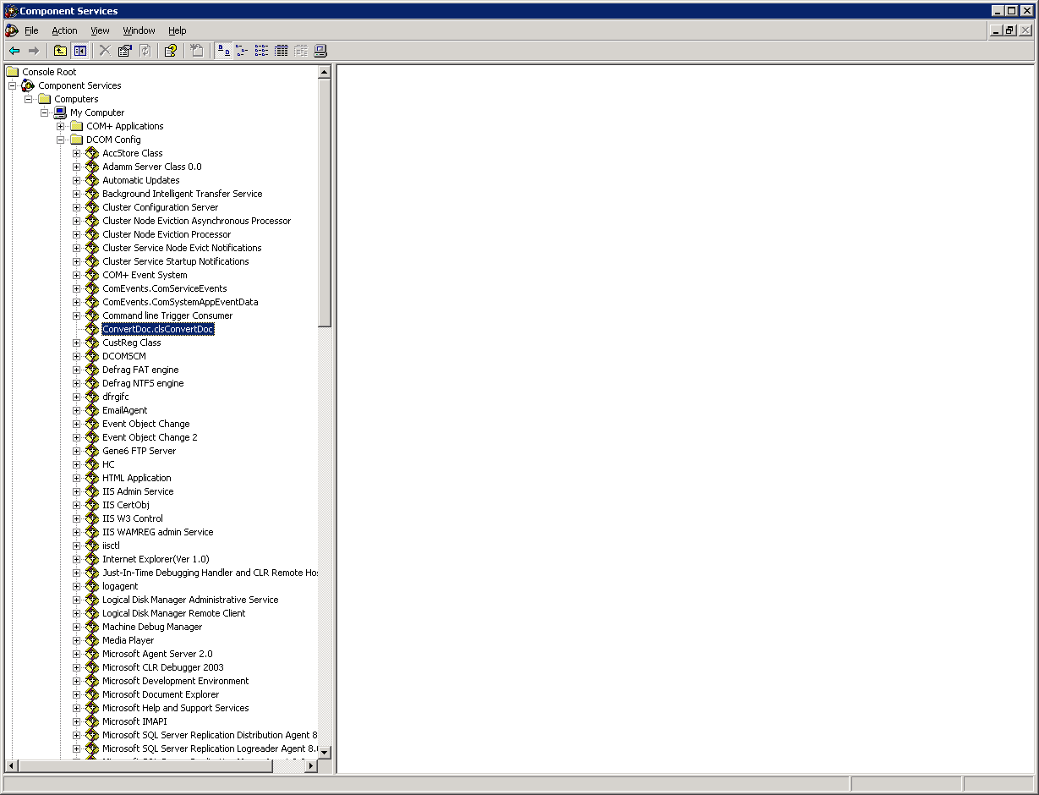

On the General Tab change the Authentication Level to None
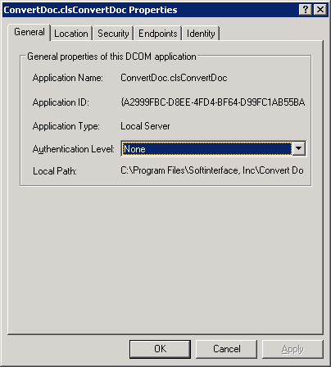

On the Identity Tab change the user account to an administrative user
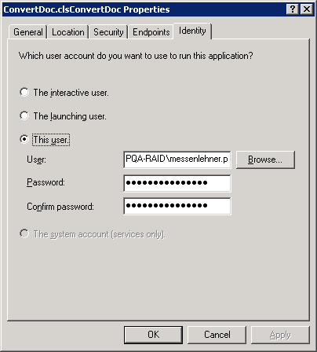

In the IIS Manager rIght click DefaultAppPool and select Properties:
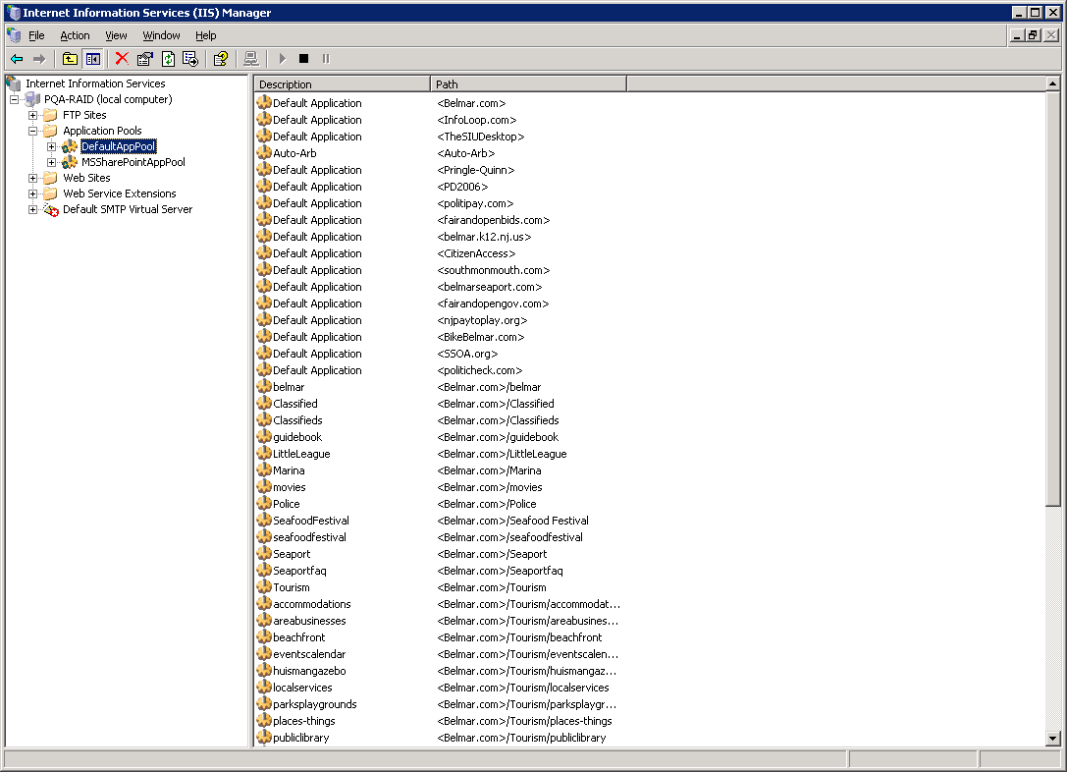

Change the Application pool identity to Predefined\Local System
